Week 8 - S8 - Core OOP - Abstract Class And Interface - Assignment Problem(HW)

**Name:**Ramesh Harisabapathi Chettiar

**Date of Submission:**07/10/25

**QNO1🡪**

Create an abstract class Shape with abstract methods area() and perimeter(). Provide a

concrete method displayInfo().

Create subclasses Circle and Rectangle that implement the abstract methods. Test the

implementation by creating objects and displaying results.

Hints:

● Use abstract keyword for Shape class.

● Implement area() and perimeter() in subclasses.

● Call displayInfo() from subclass objects.

Shape.java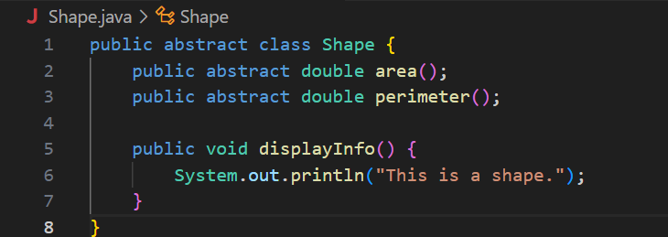

Rectangle.java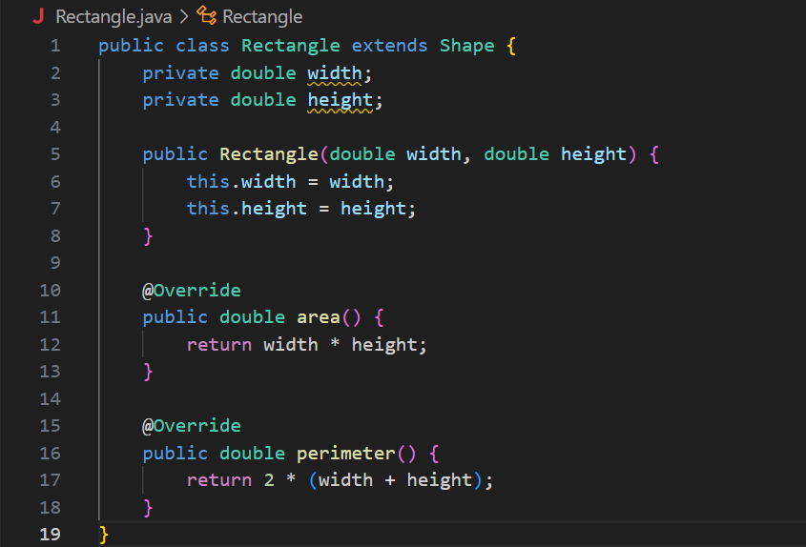

Circle.java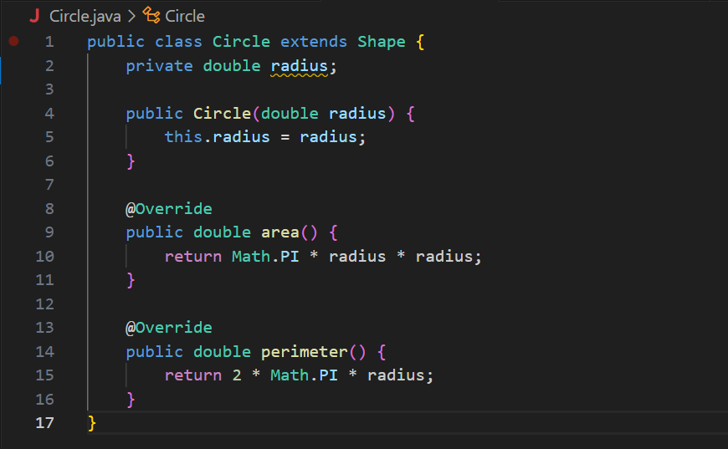

Main.java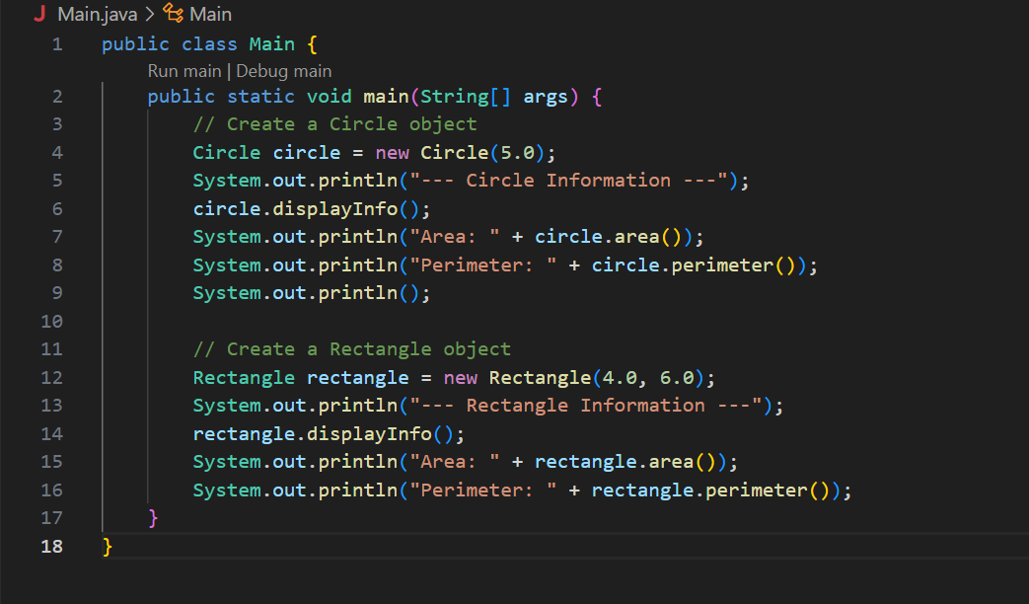

**OUTPUT🡪**

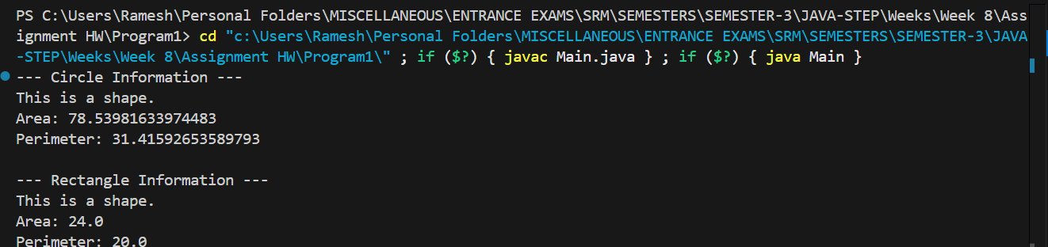

**QNO2🡪**

Create an interface Playable with methods play() and pause().

Create two classes MusicPlayer and VideoPlayer that implement this interface.

Demonstrate polymorphism by storing objects in a Playable reference and invoking methods.

Hints:

● Use interface keyword.

● Implement both methods in each class.

● Use Playable ref = new MusicPlayer(); to test polymorphism.

Playable.java

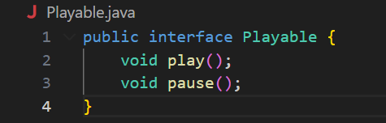

MusicPlayer.java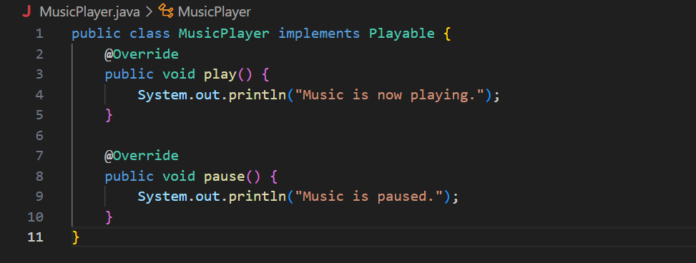

VideoPlayer.java

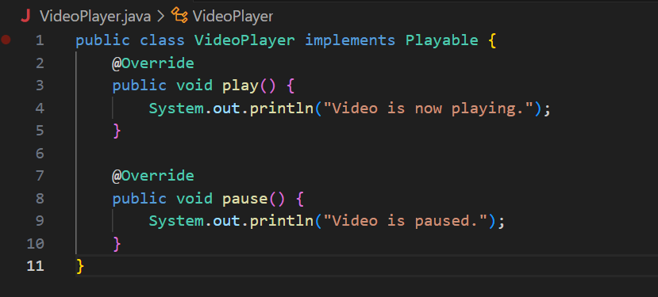

Main.java

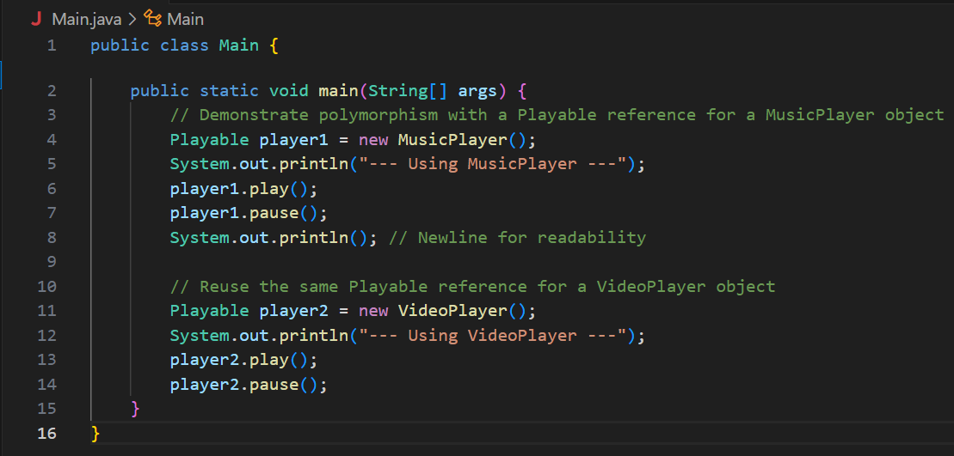

**OUTPUT🡪**

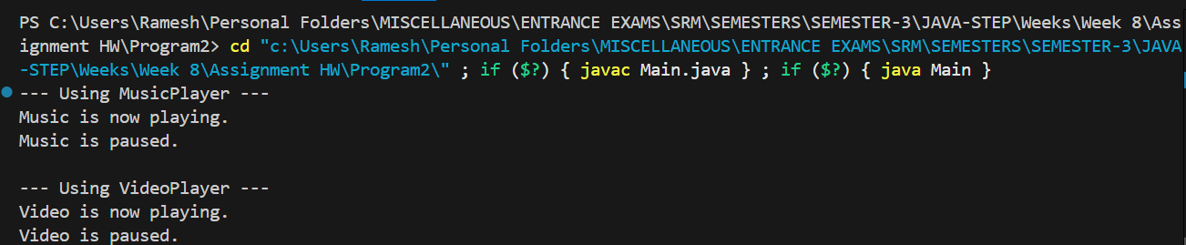

**QNO3🡪**

Create an abstract class Vehicle with abstract method start() and a concrete method

stop().

Create an interface Fuel with method refuel().

Create class Car that extends Vehicle and implements Fuel. Test all methods.

Hints:

● Use abstract class for Vehicle.

● Implement refuel() from Fuel interface in Car.

● Show method calls of start(), stop(), and refuel().

Fuel.java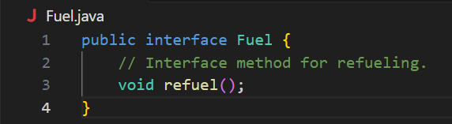

Vehicle.java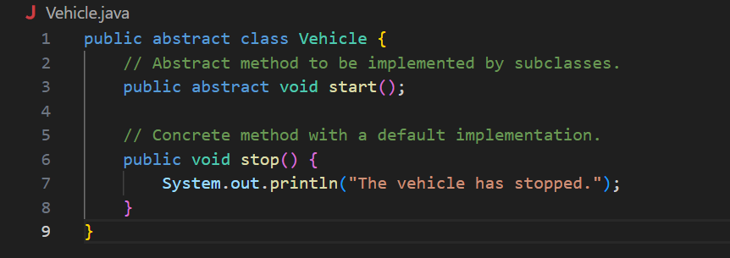

Car.java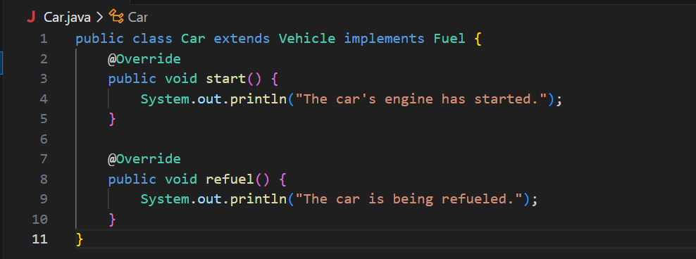

Main.java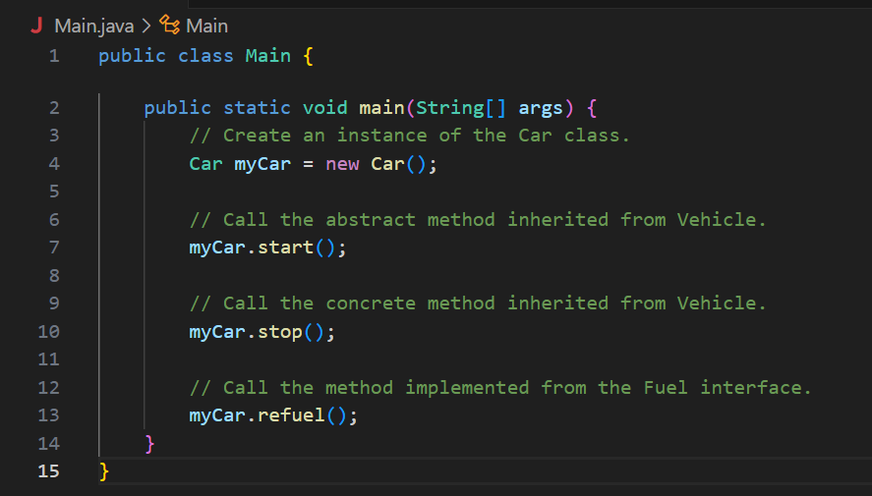

**OUTPUT🡪**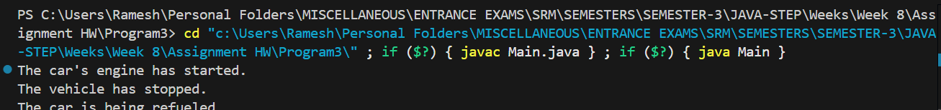

**QNO4🡪**

Create an interface Animal with method eat().

Create another interface Pet that extends Animal and adds method play().

Create a class Dog that implements Pet. Demonstrate interface inheritance in action.

Hints:

● Use interface Pet extends Animal.

● Dog must implement both eat() and play().

● Create object of Dog and test.

Animal.java

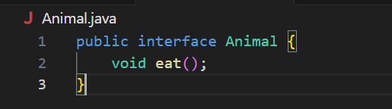

Pet.java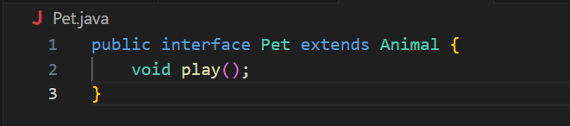

Dog.java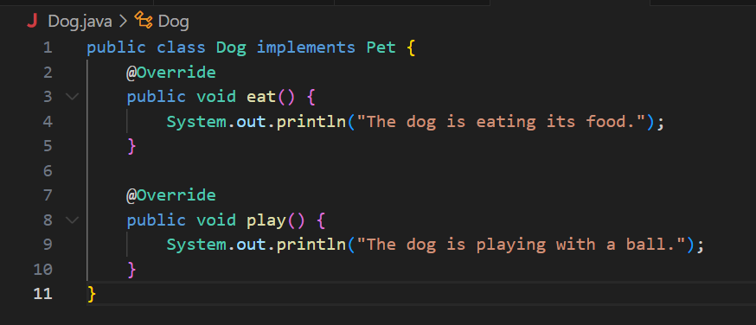

Main.java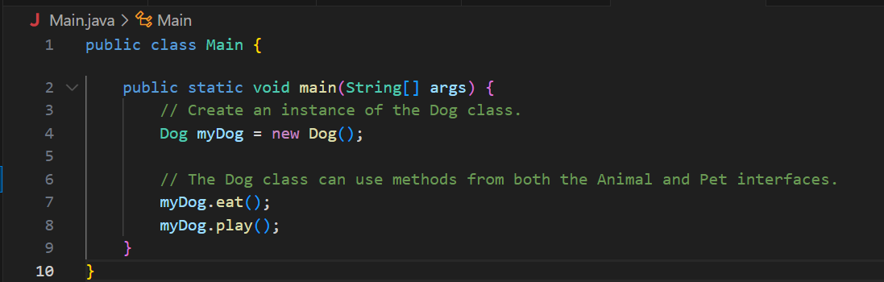

**OUTPUT🡪**

